Keeping Children Safe Online
Parental Controls:
Parental controls are tools that help parents or guardians protect their children while they use the internet. It is important parents are aware of how to use parental controls to keep children safe online.
Parental control tools can be built into devices like computers, tablets, or smartphones, as well as operating systems or internet browsers. Some internet service providers also offer parental control features. Take the time to explore these options and choose the ones that suit your needs.
Set up separate user accounts for each child on the devices they use. This allows you to customise the settings and restrictions for each child individually, depending on their age and maturity level. Adjust the settings based on your child's age and what is appropriate for them. Different age groups may require different levels of internet access and restrictions. For younger children, you might want to limit access to certain websites or block explicit content altogether.
Enable website filtering to block access to inappropriate content. Parental control tools often have pre-set filters or allow you to create custom lists of approved or blocked websites. Regularly update these filters as your child grows older and their online activities change.
Set time limits for internet usage to ensure your child doesn't spend excessive time online. This helps balance their online activities with other important aspects of their life, such as schoolwork, physical activities, and family time.
Some parental control tools allow you to control which apps or games your child can access. You can block or limit access to apps that are not suitable for their age group or restrict in-app purchases. This helps prevent them from accessing inappropriate content or spending too much time on certain apps.
Parental control tools often provide activity logs or reports that show your child's internet usage. Check these regularly to get an idea of the websites they visit, apps they use, and the duration of their online sessions. This helps you identify any potential risks or concerns.
Remember that parental controls are just one part of keeping children safe online. It's crucial to have open and ongoing conversations with your child about internet safety. Teach them about the potential risks, responsible online behaviour, and the importance of not sharing personal information with strangers.
Lastly, it's important to note that parental controls are not fool proof, and no technology can replace parental supervision and guidance. Regularly reassess and update the settings as your child grows and gains more independence. By combining parental controls with communication and education, you can help keep your children safe while they explore the online world.

Parental Controls Key Takeaways
Parent controls are there to help.
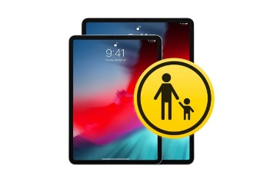
Many devices have them built in.
Everyone should have their own user accounts.
Use website filtering.
Set time limits.

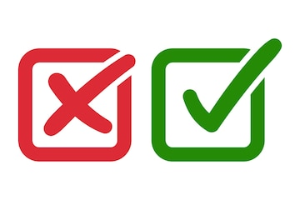
Check through what your
child has been using.

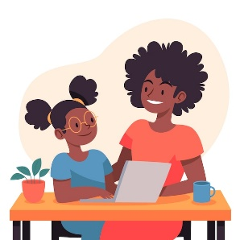
Regularly spend time with your child online.

